**A PYTHON PROGRAM TO IMPLEMENT K-MEANS MODEL**

**Ex.No:9B Date of Experiment: 25/10/2024**

**AIM:-**

To implement a python program using a K-Means Algorithm in a model.

# ALGORITHM:-

Step1: Import all the other necessary libraries(numpy as np, matplotlib.pyplot as plt and sklearn.tree,pandas as pd and seaborn as sns).

Step2: Select the number K to decide the number of clusters.

Step3: Select random K points or centroids. (It can be different from the input dataset). Step4:

Assign each data point to their closest centroid, which will form the predefined K clusters. Step5:

Calculate the variance and place a new centroid of each cluster.

Step6: Repeat the fourth steps, which means assign each datapoint to the new closest centroid of each cluster.

Step7: If any reassignment occurs, then go to step-5 else go to FINISH.

Step8: Train the model and plot the graph using scatterplot() function.

# IMPLEMENTATION:-

data = pd.read_csv('../input/k-means-clustering/KNN (3).csv') data.head(5)

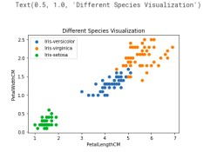

req_data = data.iloc[:,1:] req_data.head(5)

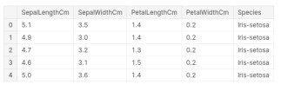

shuffle_index = np.random.permutation(req_data.shape[0]) #shuffling the row index of our dataset req_data = req_data.iloc[shuffle_index] req_data.head(5)

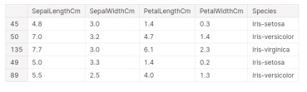

train_size = int(req_data.shape[0]*0.7)

train_df = req_data.iloc[:train_size,:] test_df = req_data.iloc[train_size:,:] train = train_df.values test = test_df.values y_true = test[:,-1] print('Train_Shape: ',train_df.shape) print('Test_Shape: ',test_df.shape)



from math import sqrt

def euclidean_distance(x_test, x_train):

distance = 0 for i in range(len(x_test)-1):

distance += (x_test[i]-x_train[i])**2

return sqrt(distance)

def get_neighbors(x_test, x_train, num_neighbors):

distances = []

data = [] for i in x_train: distances.append(euclidean_distance(x_test,i)) data.append(i)

distances = np.array(distances) data = np.array(data) sort_indexes = distances.argsort() #argsort() function returns indices by sorting distances

data in ascending order data = data[sort_indexes] #modifying our data based on sorted indices, so that we can get the

nearest neighbors return data[:num_neighbors]

def prediction(x_test, x_train, num_neighbors):

classes = []

neighbors = get_neighbors(x_test, x_train, num_neighbors)

for i in neighbors:

classes.append(i[-1])

predicted = max(classes, key=classes.count) #taking the most repeated class return predicted

def predict_classifier(x_test):

classes = []

neighbors = get_neighbors(x_test, req_data.values, 5)

for i in neighbors:

classes.append(i[-1])

predicted = max(classes, key=classes.count) print(predicted) return predicted

def accuracy(y_true, y_pred):

num_correct = 0

for i in range(len(y_true)):

if y_true[i]==y_pred[i]:

num_correct+=1

accuracy = num_correct/len(y_true) return accuracy

y_pred = [] for i in test:

y_pred.append(prediction(i, train, 5)) y_pred

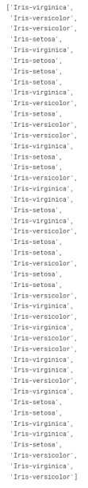

accuracy = accuracy(y_true, y_pred)

accuracy



test_df.sample(5)

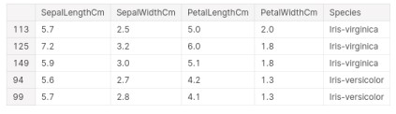

# RESULT:-

Thus the python program to implement the K-Means model has been successfully implemented and the results have been verified and analyzed.